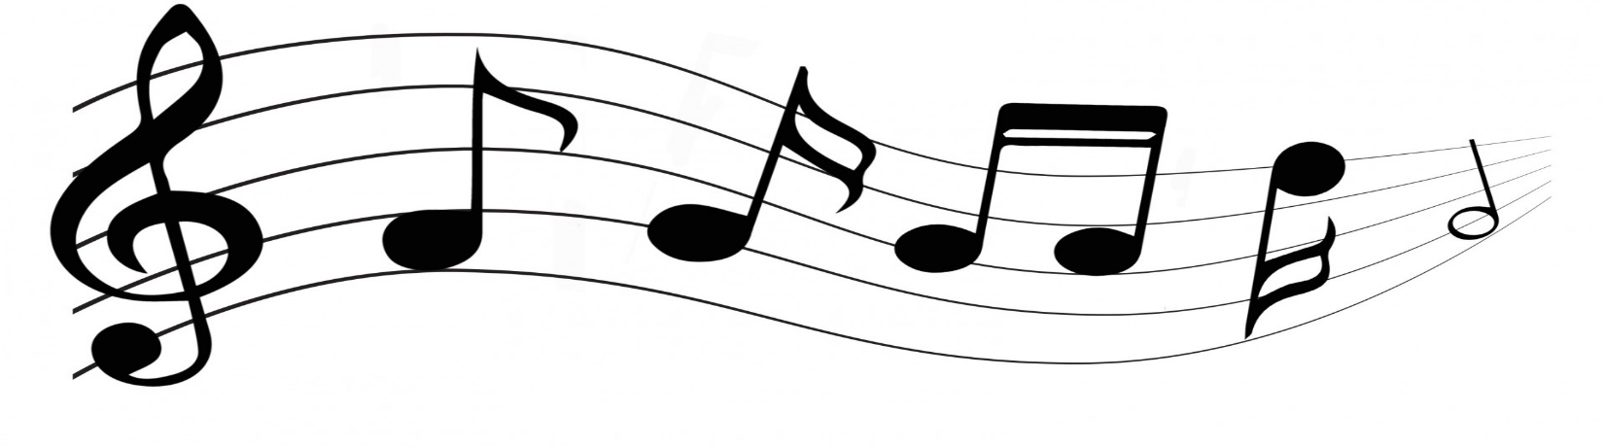
Woodside Musicians
Class of 2022
Your commemorative t-shirt is waiting for you!
Please complete this form to receive your gift
from the Woodside High School Music
Booster Organization.

Name _______________________________________________
Program ____________________________ Period _________
Adult Sizes: SM _______ M _______ L _______ XL _______
Text or Email _________________________________________
Return this form by email to
whsmbo@gmail.com
No later than April 22, 2022
Congratulations Seniors!

